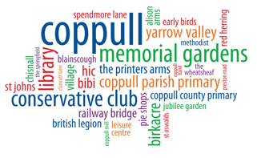 Coppull Neighbourhood Plan Update

Again, we are pleased to report progress on the Neighbourhood Plan. The plan is now at stage Regulation 14 and has been published on the Parish Council website https://www.coppull-pc.gov.uk/neighbourhoodplan There are hard copies that you can read in the following locations:
Library (currently situated in the New Village Hall, Chapel Lane)
All the pubs in the village: Alison Arms – Springfield – Red Herring – Printers Arms – Wheatsheaf
Acreswood Surgery
Springfield Leisure Centre (from the Parish Clerk’s office during opening hours)

Along with the hard copy plans there are forms for residents to complete if they wish to make a comment on any of the policies contained within the plan. These are also digitally available on the Parish Council website using the link above.

The aim of the Steering Group is to have the Neighbourhood Plan completed and adopted by March 2026.

As a Steering Group we want to thank Coppull Parish Council for their support and advice throughout.

